***Discrete Math*. Handwriting Assignment #5 Solution**

1. **Are the following two graphs isomorphic?**



**Solution) No, they are not isomorphic. The graph on the right has two vertices of degree two, but the graph on the left only has one vertex of degree two. Thus, because degree is a graph invariant, these two graphs cannot be isomorphic.**

1. **Find the adjacency matrix for the following graph**

** **

1. **Give the transitive closure of the following graph  
   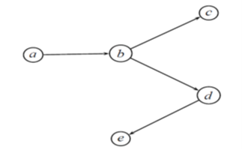  
   Ans)**

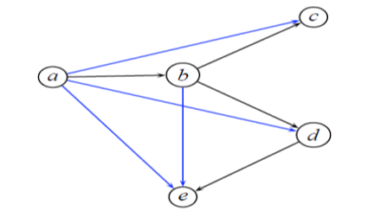

1. **Answer the questions for the following tree.  
   a) What is the height of T? b) List all of the leaves of T.  
   c)List all of the siblings of d. d)** **List all of the descendants of d.**



**Ans)**

1. **4 b) b,h,i,g,e c) e d) f, g, h, i**